- What is the ground-state electronic configuration of a carbon atom?

- 1s², 2s², 2p⁵
- 1s², 2s², 2p²
- 1s², 2s², 2p⁶

- 1s², 2s², 2p⁴

Accessibility: Keyboard Navigation

Bloom's Level: 2. Understand

Difficulty: Easy

Gradable: automatic

Section: 01.01

Subtopic: Periodic table trends

Topic: Structure and Bonding

- What is the ground-state electronic configuration of a fluorine atom?

- 1s², 2s², 2p²

- 1s², 2s², 2p³
- 1s², 2s², 2p⁴
- 1s², 2s², 2p⁵

Accessibility: Keyboard Navigation

Bloom's Level: 2. Understand

Difficulty: Easy

Gradable: automatic

Section: 01.01

Subtopic: Periodic table trends

Topic: Structure and Bonding

- What is the ground-state electronic configuration of a magnesium cation (Mg²⁺)?

- 1s², 2s², 2p⁶
- 1s², 2s², 2p⁶, 3s¹
- C. 1s², 2s², 2p⁶, 3s²

- D. 1s², 2s², 2p⁶, 3s², 3p²

Accessibility: Keyboard Navigation

Bloom's Level: 2. Understand

Difficulty: Easy

Gradable: automatic

Section: 01.01

Subtopic: Periodic table trends

Topic: Structure and Bonding

- What is the ground-state electronic configuration of a chlorine anion (Cl—)?

- 1s², 2s², 2p⁶
- 1s², 2s², 2p⁶, 3s², 3p⁶
- C. 1s², 2s², 2p⁶, 3s², 3p⁵

- D. 1s², 2s², 2p⁶, 3s², 3p⁴

- Which of the following statements about valence electrons is true?

- They are the most tightly held electrons.

- They do not participate in chemical reactions.

- They are the outermost electrons.

- They reveal the period number of a second-row element.

- Which of the following statements about bonding is true?

- Covalent bonds result from the transfer of electrons from one element to another.

- Ionic bonds result from the transfer of electrons from a metal to a non-metal.

- Ionic bonds result from the sharing of electrons between two non-metals.

- Covalent bonds result from the sharing of electrons between two metals.

Accessibility: Keyboard Navigation Bloom's Level: 2. Understand Difficulty: Easy Gradable: automatic Section: 01.01

Subtopic: Periodic table trends Topic: Structure and Bonding

Accessibility: Keyboard Navigation Bloom's Level: 2. Understand Difficulty: Easy Gradable: automatic Section: 01.01

Subtopic: Periodic table trends Topic: Structure and Bonding

Accessibility: Keyboard Navigation Bloom's Level: 1. Remember Difficulty: Easy Gradable: automatic Section: 01.02

Subtopic: Bond properties Subtopic: Types of bonds Topic: Structure and Bonding

- Which of the following would you expect to have ionic bonds?

- CO

- FBr

- NF₃

- NaCl

Accessibility: Keyboard Navigation

Bloom's Level: 3. Apply

Difficulty: Easy

Gradable: automatic

Section: 01.02

Subtopic: Bond properties

Subtopic: Types of bonds

Topic: Structure and Bonding

- Which of the following molecules has nonpolar covalent bonds?

- HCl

- N₂

- CHCl₃

- NO

9.

Accessibility: Keyboard Navigation

Bloom's Level: 2. Understand

Difficulty: Easy

Gradable: automatic

Section: 01.12

Subtopic: Bond properties

Subtopic: Types of bonds

Topic: Structure and Bonding

Which of the following molecules contain both covalent and ionic bonds?

- I, II

- I, IV

- II, III

- II, IV

Bloom's Level: 3. Apply

Difficulty: Easy

Gradable: automatic

Section: 01.02

Subtopic: Bond properties

Subtopic: Types of bonds

Topic: Structure and Bonding

10.

Arrange the following bonds in decreasing order of ionic character, putting the most ionic first.

- I > II > III > IV

- IV > II > I > III

- IV > III > II > I

- IV > II > III > I

Bloom's Level: 3. Apply

Difficulty: Easy

Gradable: automatic

Section: 01.12

Subtopic: Bond properties

Subtopic: Types of bonds

Topic: Structure and Bonding

- Which of the following statements correctly describes the typical number of bonds for carbon, nitrogen, and oxygen in most neutral organic molecules?

A.
Carbon forms 4 covalent bonds, nitrogen forms 2 covalent bonds, and oxygen forms 3 covalent bonds.

B.
Carbon forms 4 covalent bonds, nitrogen forms 3 covalent bonds, and oxygen forms 2 covalent bonds.

C.
Carbon forms 4 covalent bonds, nitrogen forms 5 covalent bonds, and oxygen forms 2 covalent bonds.

D.
Carbon forms 4 covalent bonds, nitrogen forms 5 covalent bonds, and oxygen forms 4 covalent bonds.

Accessibility: Keyboard Navigation

Bloom's Level: 1. Remember

Difficulty: Easy

Gradable: automatic

Section: 01.02

Subtopic: Bond properties

Topic: Structure and Bonding

12.

Which is not an acceptable Lewis structure for the anion CH₂NCO—?

- I

- II

- III

- IV

Bloom's Level: 4. Analyze

Difficulty: Medium

Gradable: automatic

Section: 01.03

Subtopic: Drawing Lewis structures

Subtopic: Resonance

Topic: Structure and Bonding

^{13.} Which of the following Lewis structures is correct?
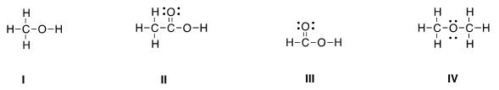

- I

- II

- III

- IV

Bloom's Level: 4. Analyze

Difficulty: Medium

Gradable: automatic

Section: 01.03

Subtopic: Drawing Lewis structures

Topic: Structure and Bonding

^{14.} Which of the following Lewis structures is correct?
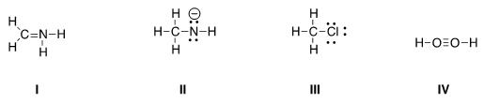

- I, II

- I, III

- II, III

- III, IV

^{15.} Which is the correct Lewis structure for acetic acid (CH₃CO₂H)?
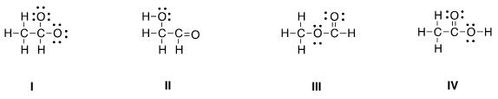

- I

- II

- III

- IV

Bloom's Level: 4. Analyze Difficulty: Medium Gradable: automatic Section: 01.03

Subtopic: Drawing Lewis structures Topic: Structure and Bonding

Bloom's Level: 4. Analyze Difficulty: Medium Gradable: automatic Section: 01.03

Subtopic: Drawing Lewis structures Topic: Structure and Bonding

^{16.} In which of the following ions does carbon have a formal charge?
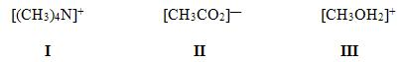

- I

- II

- III

- None of these

Bloom's Level: 1. Remember

Difficulty: Easy

Gradable: automatic

Section: 01.03

Subtopic: Formal charges

Topic: Structure and Bonding

^{17.} In which of the following ions does carbon have a formal charge?
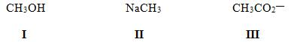

- I

- II

- III

- None of these

Bloom's Level: 1. Remember

Difficulty: Easy

Gradable: automatic

Section: 01.03

Subtopic: Formal charges

Topic: Structure and Bonding

18. What is the formal charge of carbon in carbon monoxide (CO) when drawn with a triple bond?

- 0

- -2

- -1

- +1

Accessibility: Keyboard Navigation

Bloom's Level: 4. Analyze

Difficulty: Medium

Gradable: automatic

Section: 01.03

Subtopic: Drawing Lewis structures

Subtopic: Formal charges

Topic: Structure and Bonding

19. Which of the following statements about constitutional isomers is true?

A.

Constitutional isomers are different molecules having the different molecular formula.

B. Constitutional isomers are different molecules having the same molecular formula.

C.

Constitutional isomers are same molecules having the different molecular formula.

D. Constitutional isomers are same molecules having the same molecular formula.

Accessibility: Keyboard Navigation

Bloom's Level: 1. Remember

Difficulty: Easy

Gradable: automatic

Section: 01.04

Subtopic: Constitutional isomers

Topic: Structure and Bonding

20. How many constitutional isomers are there for a molecule having the molecular formula C₂H₆O?

- 1

- 2

- 3

- 4

Accessibility: Keyboard Navigation

Bloom's Level: 4. Analyze

Difficulty: Easy

Gradable: automatic

Section: 01.04

Subtopic: Constitutional isomers

Topic: Structure and Bonding

^{21.} How many constitutional isomers are there for a molecule having the molecular formula C₃H₈O?

- 1

- 2

- 3

- 4

Accessibility: Keyboard Navigation

Bloom's Level: 4. Analyze

Difficulty: Easy

Gradable: automatic

Section: 01.04

Subtopic: Constitutional isomers

Topic: Structure and Bonding

22. How many constitutional isomers are there for a molecule having the molecular formula C₃H₆?

- 1

- 2

- 3

- 4

Accessibility: Keyboard Navigation

Bloom's Level: 4. Analyze

Difficulty: Easy

Gradable: automatic

Section: 01.04

Subtopic: Constitutional isomers

Topic: Structure and Bonding

23. How many constitutional isomers are there for a molecule having the molecular formula C₂H₄Cl₂?

- 1

- 2

- 3

- 4

Accessibility: Keyboard Navigation

Bloom's Level: 4. Analyze

Difficulty: Medium

Gradable: automatic

Section: 01.04

Subtopic: Constitutional isomers

Topic: Structure and Bonding

24. How many different isomers are there for a compound having the molecular formula C₃H₆O?

- 4

- 5

- 6

- 7

Accessibility: Keyboard Navigation

Bloom's Level: 4. Analyze

Difficulty: Medium

Gradable: automatic

Section: 01.04

Subtopic: Constitutional isomers

Topic: Structure and Bonding

^{25.} Which of the following molecules are constitutional isomers?

- I, II, IV

- II, III, IV

- I, III, IV

- I, II, III

Bloom's Level: 4. Analyze

Difficulty: Easy

Gradable: automatic

Section: 01.04

Subtopic: Constitutional isomers

Topic: Structure and Bonding

26. Which of the following compounds has an atom with an unfilled valence shell of electrons?

- H₂O

- BCl₃

- CH₄
- CO₂

Accessibility: Keyboard Navigation

Bloom's Level: 4. Analyze

Difficulty: Medium

Gradable: automatic

Section: 01.05

Subtopic: Octet rule

Subtopic: Octet rule exception

Topic: Structure and Bonding

27. Which of the following statements about resonance structures is true?

- Resonance structures have the same placement of electrons but different arrangement of atoms.

- Resonance structures have the same placement of atoms but different arrangement of electrons.

- Resonance structures have the same placement of atoms and the same arrangement of electrons.

- Resonance structures have different placement of atoms and different arrangement of electrons.

Accessibility: Keyboard Navigation

Bloom's Level: 2. Understand

Difficulty: Easy

Gradable: automatic

Section: 01.06

Subtopic: Constitutional isomers

Subtopic: Resonance

Topic: Structure and Bonding

28. Which of the following statements about resonance structures is not true?

- There is no movement of electrons from one form to another.

- Resonance structures are not isomers.

- Resonance structures differ only in the arrangement of electrons.

- Resonance structures are in equilibrium with each other.

Accessibility: Keyboard Navigation

Bloom's Level: 2. Understand

Difficulty: Easy

Gradable: automatic

Section: 01.06

Subtopic: Constitutional isomers

Subtopic: Resonance

Topic: Structure and Bonding

29.

Which of the following pair does not represent resonance structures?
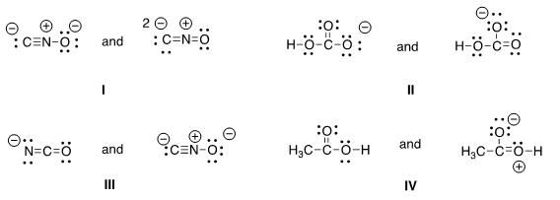

- I

- II

- III

- IV

Bloom's Level: 4. Analyze

Difficulty: Medium

Gradable: automatic

Section: 01.06

Subtopic: Drawing Lewis structures

Subtopic: Resonance

Topic: Structure and Bonding

30. What 2 things will change between two resonance structures?

- The position of multiple bonds and non-bonded electrons.

- The position of multiple bonds and single bonds.

- The placement of atoms and single bonds.

- The placement of atoms and non-bonded electrons.

^{31.} Which of the following is a resonance structure of the compound below?
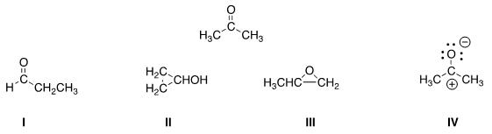

- I

- II

- III

- IV

Accessibility: Keyboard Navigation Bloom's Level: 2. Understand Difficulty: Easy Gradable: automatic Section: 01.06 Subtopic: Resonance

Topic: Structure and Bonding

Bloom's Level: 3. Apply Difficulty: Medium Gradable: automatic Section: 01.06

Subtopic: Drawing Lewis structures Subtopic: Resonance Topic: Structure and Bonding

- Which of the following resonance structures is the least important contributor to the resonance hybrid of the formate anion, HCOO—?

- I

- II

- III

- IV

Bloom's Level: 3. Apply

Difficulty: Hard

Gradable: automatic

Section: 01.06

Subtopic: Drawing Lewis structures

Subtopic: Resonance

Topic: Structure and Bonding

- Rank the following in order of decreasing importance as contributing structures to the resonance hybrid of formaldehyde, H₂CO.
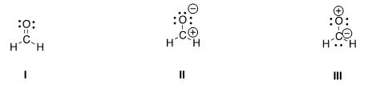

- I > II > III

- I > III > II

- II > I > III

- III > II > I

Bloom's Level: 3. Apply

Difficulty: Hard

Gradable: automatic

Section: 01.06

Subtopic: Drawing Lewis structures

Subtopic: Resonance

Topic: Structure and Bonding

34.

Follow the curved arrows to draw the second resonance structure for the ion below.
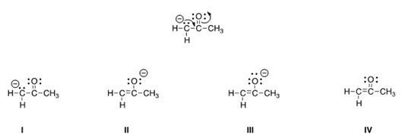

- I

- II

- III

- IV

Bloom's Level: 2. Understand

Difficulty: Medium

Gradable: automatic

Section: 01.06

Subtopic: Drawing Lewis structures

Subtopic: Resonance

Topic: Structure and Bonding

^{35.} Which is more important in each pair of contributing resonance structures?
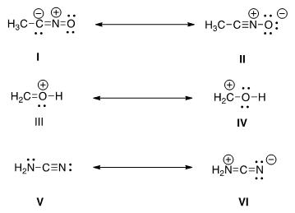

- II, IV, V

- II, III, V

- II, III, VI

- I, IV, V

36. What is the approximate value of the H-C-H bond angle in methane, CH₄?

- 90°

- 109.5°

- 120°

- 180°

Bloom's Level: 4. Analyze Difficulty: Medium Gradable: automatic Section: 01.06

Subtopic: Drawing Lewis structures Subtopic: Resonance Topic: Structure and Bonding

Accessibility: Keyboard Navigation Bloom's Level: 1. Remember Difficulty: Easy Gradable: automatic Section: 01.07

Subtopic: Hybridization Subtopic: VSEPR theory Topic: Molecular Shape

^{37.} What is the approximate C-C-C bond angle in propene, CH₃CH = CH₂?

- 90°

- 109.5°

- 120°

- 180°

38. What is the approximate H-C-O bond angle in formaldehyde, H₂CO?

- 90°

- 109.5°

- 120°

- 180°

^{39.} Determine the geometry around the indicated atom in each species.
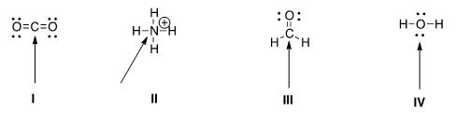

- I = Linear; II = tetrahedral; III = trigonal planar; IV = tetrahedral

- I = Linear; II = tetrahedral; III = trigonal planar; IV = linear

- I = Trigonal planar; II = linear; III = tetrahedral; IV = trigonal planar

- I = Tetrahedral; II = trigonal planar; III = linear; IV = tetrahedral

Accessibility: Keyboard Navigation Bloom's Level: 2. Understand Difficulty: Easy Gradable: automatic Section: 01.07

Subtopic: Hybridization Subtopic: VSEPR theory Topic: Molecular Shape

Accessibility: Keyboard Navigation Bloom's Level: 2. Understand Difficulty: Medium Gradable: automatic Section: 01.07

Subtopic: Hybridization Subtopic: VSEPR theory Topic: Molecular Shape

Bloom's Level: 1. Remember Difficulty: Easy Gradable: automatic Section: 01.07

Subtopic: Hybridization Subtopic: VSEPR theory Topic: Molecular Shape

40. What is the approximate bond angle for the C-C-N bond in acetonitrile, CH₃CN?

- 90°

- 109.5°

- 120°

- 180°

Accessibility: Keyboard Navigation

Bloom's Level: 4. Analyze

Difficulty: Medium

Gradable: automatic

Section: 01.07

Subtopic: Drawing Lewis structures

Subtopic: Hybridization

Subtopic: VSEPR theory

Topic: Molecular Shape

^{41.} Which of the following is the appropriate conversion of the condensed structure, CH₃COCH₃, to a Lewis structure?
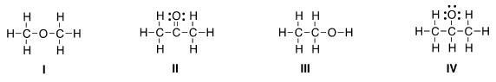

- I

- II

- III

- IV

Bloom's Level: 2. Understand

Difficulty: Medium

Gradable: automatic

Section: 01.08

Subtopic: Condensed formula

Subtopic: Drawing Lewis structure

Topic: Drawing Organic Molecules

^{42.} Which of the following is the appropriate conversion of (CH₃)₂CHCH₂CHClCH₃ to a skeletal structure?
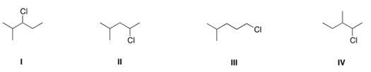

- I

- II

- III

- IV

Bloom's Level: 2. Understand

Difficulty: Medium

Gradable: automatic

Section: 01.08

Subtopic: Condensed formula

Subtopic: Skeletal/bond-line structures

Topic: Drawing Organic Molecules

^{43.} Which of the following is the appropriate conversion of (CH₃)₄C to a skeletal structure?

- I

- II

- III

- IV

Bloom's Level: 2. Understand

Difficulty: Easy

Gradable: automatic

Section: 01.08

Subtopic: Condensed formula

Subtopic: Skeletal/bond-line structures

Topic: Drawing Organic Molecules

^{44.} What is the condensed formula of the compound below?
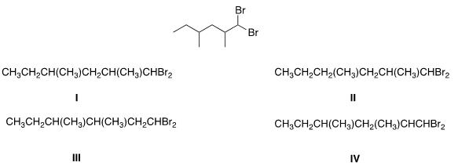

- I

- II

- III

- IV

Bloom's Level: 2. Understand

Difficulty: Medium

Gradable: automatic

Section: 01.08

Subtopic: Condensed formula

Subtopic: Skeletal/bond-line structures

Topic: Drawing Organic Molecules

^{45.} Which of the following is the appropriate conversion of (CH₃)₂CHOCH₂CH₂CH₂OH to a skeletal structure?
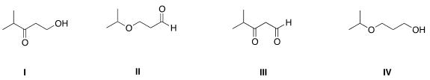

- I

- II

- III

- IV

Bloom's Level: 2. Understand

Difficulty: Medium

Gradable: automatic

Section: 01.08

Subtopic: Condensed formula

Subtopic: Skeletal/bond-line structures

Topic: Drawing Organic Molecules

46.

Convert the following skeletal structure to a condensed structure.
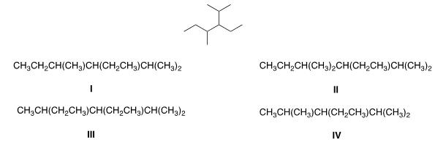

- I

- II

- III

- IV

Bloom's Level: 2. Understand

Difficulty: Medium

Gradable: automatic

Section: 01.08

Subtopic: Condensed formula

Subtopic: Skeletal/bond-line structures

Topic: Drawing Organic Molecules

- Avobenzone is an active ingredient in some common sunscreens. Which of the following is the correct molecular formula for avobenzone?
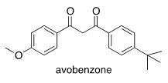

- C₂₂O₂₂O₃

- C₂₀H₂₂O₃
- C₂₁H₂₃O₃
- C₂₀H₂₄O₃

Bloom's Level: 3. Apply

Difficulty: Medium

Gradable: automatic

Section: 01.08

Subtopic: Condensed formula

Subtopic: Skeletal/bond-line structures

Topic: Drawing Organic Molecules

^{48.} In which structure is the hybridization incorrect?

- I

- II

- III

- IV

^{49.} What is the hybridization for each of the indicated atoms in the following compound?
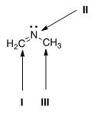

- I = sp²; II = sp²; III = sp².
- I = sp²; II = sp³; III = sp³.
- I = sp; II = sp²; III = sp³.

- I = sp²; II = sp²; III = sp³.

Bloom's Level: 2. Understand Difficulty: Medium Gradable: automatic Section: 01.09

Subtopic: Hybridization Subtopic: Valence bond theory Topic: Molecular Shape

Bloom's Level: 2. Understand Difficulty: Medium Gradable: automatic Section: 01.09

Subtopic: Hybridization Subtopic: Valence bond theory Topic: Molecular Shape

50. What is the hybridization of the carbon atom in the methyl cation, (CH₃⁺)?

- sp³
- sp²
- sp

- p

Accessibility: Keyboard Navigation

Bloom's Level: 2. Understand

Difficulty: Medium

Gradable: automatic

Section: 01.09

Subtopic: Hybridization

Subtopic: Valence bond theory

Topic: Molecular Shape

51. What is the hybridization of the nitrogen atom in the ammonium cation, NH₄⁺?

- sp³
- sp²
- sp

- p

Accessibility: Keyboard Navigation

Bloom's Level: 2. Understand

Difficulty: Medium

Gradable: automatic

Section: 01.09

Subtopic: Hybridization

Subtopic: Valence bond theory

Topic: Molecular Shape

^{52.} Which atomic orbitals overlap to form the C-H s bonding molecular orbitals of ethane, CH₃CH₃?

- Csp² + H1s

- Csp³ + H1s
- C2p + H1s

- Csp + H1s

Accessibility: Keyboard Navigation

Bloom's Level: 3. Apply

Difficulty: Medium

Gradable: automatic

Section: 01.10

Subtopic: Atomic orbitals

Subtopic: Hybridization

Subtopic: Valence bond theory

Topic: Molecular Shape

^{53.} Which atomic orbitals overlap to form the C-H s bonding molecular orbitals of ethylene, H₂C=CH₂?

- C2p + H1s

- Csp + H1s

- Csp³ + H1s

- Csp² + H1s

Accessibility: Keyboard Navigation

Bloom's Level: 3. Apply

Difficulty: Medium

Gradable: automatic

Section: 01.10

Subtopic: Atomic orbitals

Subtopic: Hybridization

Subtopic: Molecular orbital theory

Topic: Molecular Shape

54. Which atomic orbitals overlap to form the carbon-carbon s and p bonding molecular orbitals of ethylene, H₂C=CH₂?

- Csp³ + Csp³, and C2p + C2p
- Csp³ + Csp³, and Csp² + Csp²

- C. Csp² + Csp², and C2p + C2p
- D. Csp² + Csp², and Csp² + Csp²

Accessibility: Keyboard Navigation

Bloom's Level: 3. Apply

Difficulty: Medium

Gradable: automatic

Section: 01.10

Subtopic: Atomic orbitals

Subtopic: Hybridization

Subtopic: Molecular orbital theory

Topic: Molecular Shape

^{55.} Which atomic orbitals overlap to form the C-H s bonding molecular orbitals of acetylene, C₂H₂?

- Csp + H1s

- C2p +H1s

- Csp³ + H1s

- Csp² + H1s

Accessibility: Keyboard Navigation

Bloom's Level: 3. Apply

Difficulty: Medium

Gradable: automatic

Section: 01.10

Subtopic: Atomic orbitals

Subtopic: Hybridization

Subtopic: Molecular orbital theory

Topic: Molecular Shape

56. Which atomic orbitals overlap to form the carbon-carbon s bonding molecular orbital of acetylene, C₂H₂?

- Csp² + Csp²
- Csp + Csp

- Csp³ + Csp³

- C2p + C2p

Accessibility: Keyboard Navigation

Bloom's Level: 3. Apply

Difficulty: Medium

Gradable: automatic

Section: 01.10

Subtopic: Atomic orbitals

Subtopic: Hybridization

Subtopic: Molecular orbital theory

Topic: Molecular Shape

- When forming molecular orbitals from atomic orbitals, what is the order of increasing C-H bond strength for the following set?
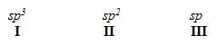

- II < I < III

- III < I < II

- III < II < I

- I < II < III

Bloom's Level: 3. Apply

Difficulty: Medium

Gradable: automatic

Section: 01.11

Subtopic: Atomic orbitals

Subtopic: Hybridization

Subtopic: Molecular orbital theory

Topic: Molecular Shape

58.

What is the order of decreasing bond length for a C-C bond composed of the following molecular orbitals?
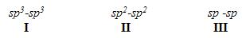

- I > III > II

- I > II > III

- III > II > I

- II > III > I

Bloom's Level: 3. Apply

Difficulty: Medium

Gradable: automatic

Section: 01.11

Subtopic: Atomic orbitals

Subtopic: Hybridization

Subtopic: Molecular orbital theory

Topic: Molecular Shape

59. Which of the following statements about electronegativity and the periodic table is true?

- Electronegativity decreases across a row of the periodic table.

- Electronegativity increases down a column of the periodic table.

- Electronegativity increases across a row of the periodic table.

- Electronegativity does not change down a column of the periodic table.

60.

Accessibility: Keyboard Navigation

Bloom's Level: 2. Understand

Difficulty: Medium

Gradable: automatic

Section: 01.12

Subtopic: Dipole moments

Topic: Molecular Shape

Rank the following atoms in order of increasing electronegativity, putting the least electronegative first.

- I < II < III < IV

- I < IV < II < III

- III < II < IV < I

- I < II < IV < III

Bloom's Level: 3. Apply

Difficulty: Medium

Gradable: automatic

Section: 01.12

Subtopic: Dipole moments

Topic: Molecular Shape

^{61.} Rank the following atoms in order of decreasing electronegativity, putting the most electronegative first.

- I > IV > II > III

- II > III > IV > I

- III > IV > II > I

- III > II > IV > I

Bloom's Level: 3. Apply

Difficulty: Medium

Gradable: automatic

Section: 01.12

Subtopic: Dipole moments

Topic: Molecular Shape

62. Which molecule has the greatest difference in electronegativity (DE) between the two different elements?

- CO₂

- H₂S
- NH₃
- H₂O

Accessibility: Keyboard Navigation

Bloom's Level: 3. Apply

Difficulty: Medium

Gradable: automatic

Section: 01.12

Subtopic: Dipole moments

Topic: Molecular Shape

^{63.} Which compound contains the most polar bond?

- I

- II

- III

- IV

Bloom's Level: 3. Apply

Difficulty: Medium

Gradable: automatic

Section: 01.12

Subtopic: Dipole moments

Topic: Molecular Shape

^{64.} Which of the following compounds are non-polar?

- I, IV

- I, II

- II, III

- II, IV

Bloom's Level: 3. Apply

Difficulty: Medium

Gradable: automatic

Section: 01.13

Subtopic: Dipole moments

Subtopic: Polarity of molecules

Topic: Molecular Shape

65. Which of the following molecules has non-polar covalent bonds?

- CO₂

- N₂
- CCl₄
- HF

Accessibility: Keyboard Navigation

Bloom's Level: 2. Understand

Difficulty: Medium

Gradable: automatic

Section: 01.12

Subtopic: Dipole moments

Topic: Molecular Shape

66. Which of the following molecules has polar covalent bonds?

- MgO

- NH₃

- Cl₂
- NaBr

Accessibility: Keyboard Navigation

Bloom's Level: 2. Understand

Difficulty: Medium

Gradable: automatic

Section: 01.12

Subtopic: Dipole moments

Topic: Molecular Shape

67. Which of the following covalent bonds has the largest dipole moment?

- C-H

- C-C

- C-O

- H-F

Accessibility: Keyboard Navigation

Bloom's Level: 3. Apply

Difficulty: Medium

Gradable: automatic

Section: 01.12

Subtopic: Dipole moments

Topic: Molecular Shape

68. Which of the following molecules has the smallest dipole moment?

- CO₂

- HCl

- H₂O

- NH₃

Accessibility: Keyboard Navigation

Bloom's Level: 2. Understand

Difficulty: Medium

Gradable: automatic

Section: 01.12

Subtopic: Dipole moments

Topic: Molecular Shape

69. Which of the following molecules does not have a net dipole moment of zero?

- CCl₄

- BF₃
- CO₂
- NH₃

Accessibility: Keyboard Navigation

Bloom's Level: 2. Understand

Difficulty: Medium

Gradable: automatic

Section: 01.13

Subtopic: Dipole moments

Subtopic: Polarity of molecules

Topic: Molecular Shape

70.

Which of the following molecules has a net dipole moment of zero?

- I

- II

- III

- IV

Bloom's Level: 4. Analyze

Difficulty: Medium

Gradable: automatic

Section: 01.13

Subtopic: Dipole moments

Subtopic: Polarity of molecules

Topic: Molecular Shape

- Consider compounds which contain both a heteroatom and a double bond. For which compound is no additional Lewis structure possible?
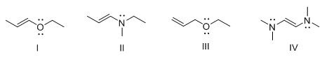

- I

- II

- III

- IV

Bloom's Level: 4. Analyze

Difficulty: Hard

Gradable: automatic

Section: 01.06

Subtopic: Drawing Lewis structures

Subtopic: Resonance

Topic: Structure and Bonding

